Geometry: Unit 6, Lesson 8
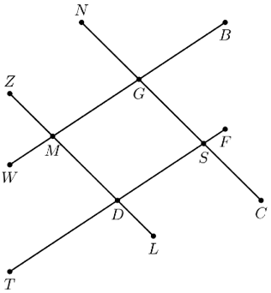
- Line segments $WB$, $TF$, $NC$, and $ZL$ are shown. $∠NGM≅∠DSG$. Based on the given information, what is a statement that can be proved?

$$\overline{WB}∥\overline{TF}$$

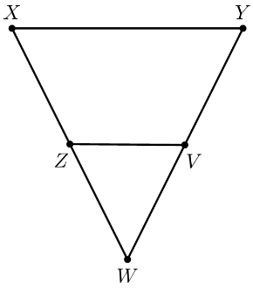
- Triangles $XYW$ and $VWZ$ are shown. $\overline{XY}∥\overline{ZV}$. What is the relationship between $∠ZXY$ and $∠VZW$?

$∠ZXY≅∠VZW$ because they are corresponding angles

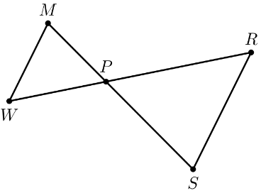
- Triangles $MWP$ and $SRP$ are shown. Why is $∠MPW≅∠SPR$?

If two lines intersect, then vertical angles are congruent

